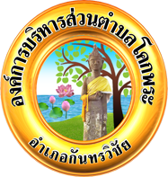

**Announcement of Kokpra Subdistrict Administrative Organization**

**Subject: Policy of Not Accepting All Kinds of Presents and Gifts**

**from Performing Duties (No Gift Policy)**

***********************************************

Kokpra Subdistrict Administrative Organization, as a juristic person and a local, administration government, has been authorized to provide public services to citizens residing in the area of Kokpra Subdistrict Administrative Organization The said duty has been operated under The Act of District Assembly and District Administrative Organization B.E. 2537 (1994) and the amendments (No.2). In addition, human resource management of Kokpra Subdistrict Administrative Organization has been in accordance with Local Personal Administration B.E. 2542 (1999) and has supported the plan on the driving of reformation activities which will lead to significant changes to people's lives (Big Rock) under the National Reformation Program (revision) on Prevention and Suppression of Corruption and Misconduct No. 5.4 on atransparent city under Strategic Issue No. 5 on promoting the creation of a participatory democratic city of the revised 20-Year (B.E. 2561-2580)

In order to strengthen the organizational culture as well as honesty and integrity in carrying out tasks with virtue and ethics, performing duties without conflict of interest, and preventing corruption, Kokpra Subdistrict Administrative Organization has set up the Policy of Not Accepting All Kinds of Presents and Gifts from Performing Duties (No Gift Policy). Kokpra Subdistrict Administrative Organization is an agency whose civil officials, personnel, and persons who perform other duties in agencies under Kokpra Subdistrict Administrative Organization do not accept all kinds of presents and gifts from performing duties as follows:

1. Kokpra Subdistrict Administrative Organization civil officials and personnel refrain from accepting all kinds of presents and gifts, or any other benefit as well as accepting hosted meals offered by outsiders who have made a contact with Kokpra Subdistrict Administrative Organization before, during and after performing duties;

2. Kokpra.

-2-

2. Kokpra Subdistrict Administrative Organization civil officials and personnel refrain from giving all kinds of presents and gifts to outsiders who have made a contact with Kokpra Subdistrict Administrative Organization before, during ,and after performing duties;

3. Kokpra Subdistrict Administrative Organization civil officials and personnel shall not seek all kinds of presents and gifts or any other benefit before, during, and after performing duties;

4.Expression of congratulations, best wishes, welcome , or condolences in traditional occasions should be done by signing in blessing cards, blessing books, condolence cards, or using the social medial instead of giving things;

5.Superiors of all levels shall behave according to the professional code of ethics and be good role models and supervise affiliated officials to behave well, act properly and strictly, and insist on fighting against all kinds of corruption;

6. Kokpra Subdistrict Administrative Organization civil officials and personnel are authorized to inform all outsiders of the Policy;

7. Any actions under this Policy shall follow the designated guideline as well as other ones deemed suitably regulated by Pong Subdistrict Administrative Organization afterward to comply with this Policy.

This Announcement shall be informed and observed accordingly.

Announced on 17  February 2025

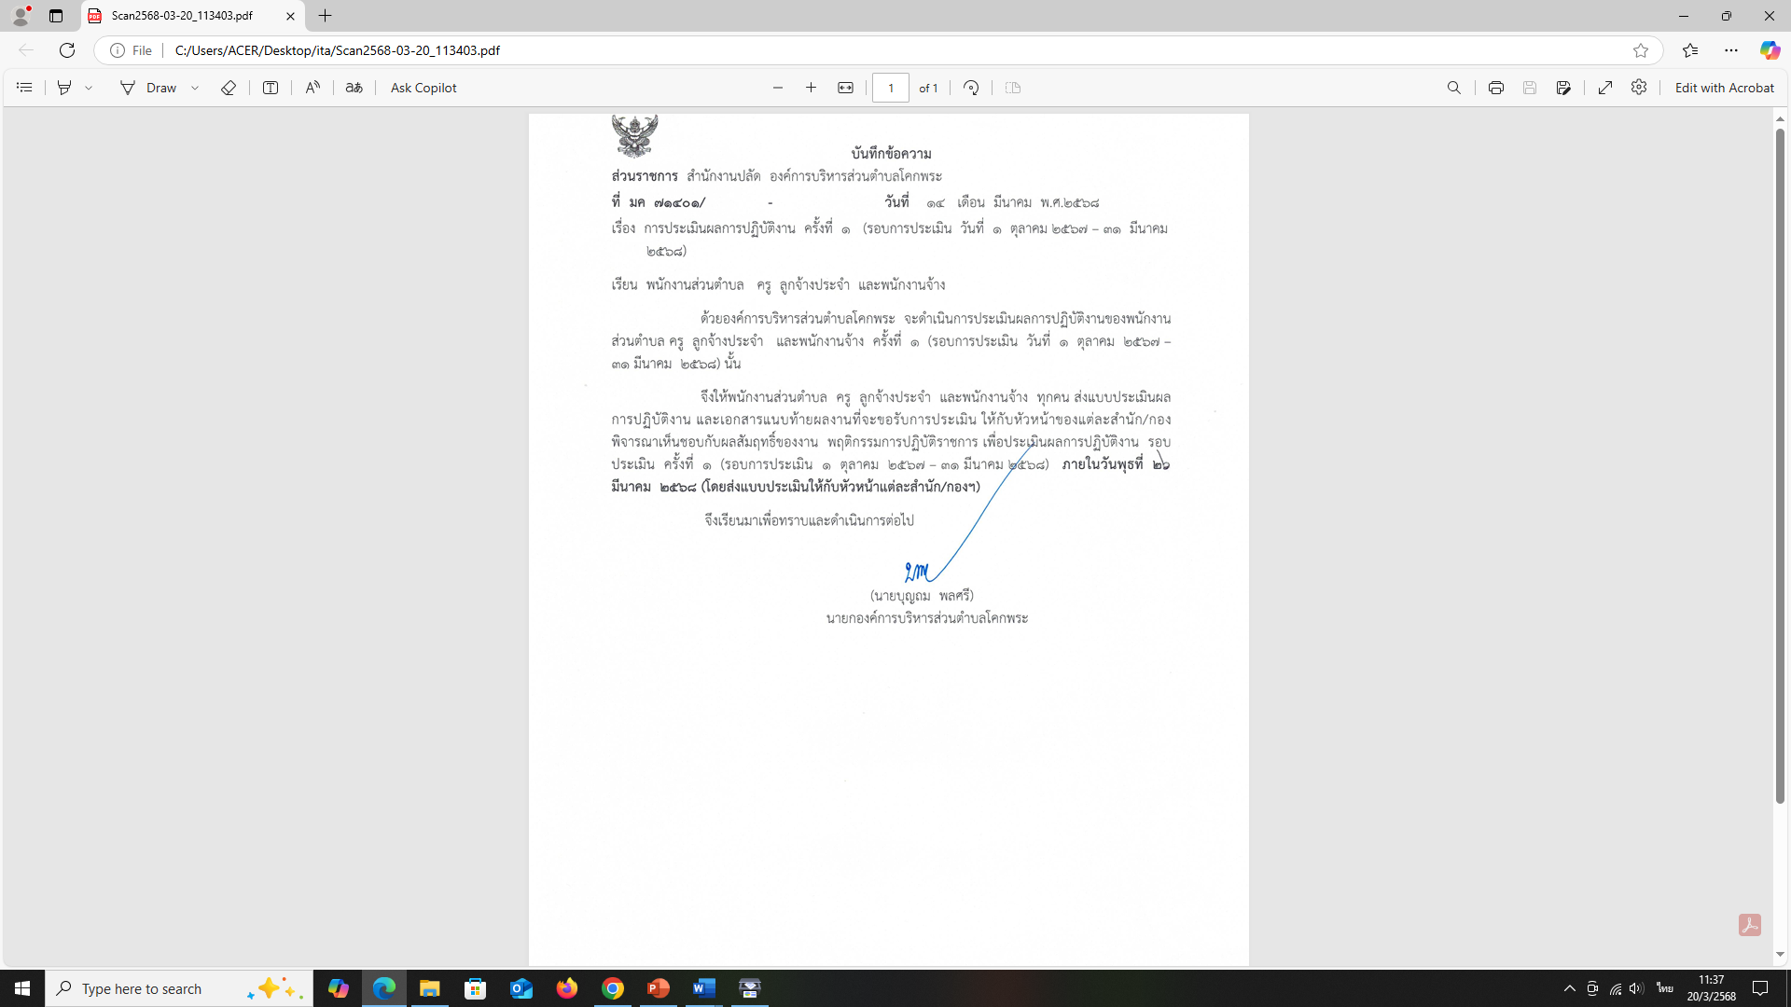

(Mr.Bunthom Phonsri)

Director of Kokpra Subdistrict Administrative Organization